韩灵全：

DP:

(一)概念总结

1.Bellman-Ford 算法也可以在无向图中run，但是此时要保证图中不能有负边，但是因为它的时间复杂度是O(VE),所以不如果Dijkstr。

2.强制在有负圈的图中run Bellman-ford其实也可以得到部分点的准确最短距离

3.所有的DP问题，如果用iteration来求解，就必须从base case来计算，如果题目提供的变量不满足我们填表的顺序，就需要对这种变量进行排序（15 fall最后一道DP题）

(二）题型总结

DP问题从问题本身的解决方式来分，分为**选不选问题**和**问题的缩放**两种类型。

其中背包问题属于选不选问题，断点问题属于缩放问题。

DP问题——backtracking思路：就是看从最优解的位置判断它是等于之前的那个子问题的最优解，如果找到了这个子问题，那就pop出这个子问题的坐标，然后重复这个过程，直到base-case

DP问题——时间复杂度的计算：

简单的方法是：写处伪代码，看出有几个loop，和每次loop的时间、

或者: 先考虑有多少个子问题（或者说有是一张多大的表格要填写），然后看每个子问题的处理时间是多少（也就是调写表格中的每个cell要多少时间）

全部问题的时间复杂度，针对题目的要求，也就是题目准确想要的最优解在表格中的位置，可以把去不问题的时间复杂度减少化解

（DP中需要注意的问题是不要忽略initialization和对 recurrence Formula 的limitation的考虑）

下面是一些含有明显特征的题型总结和大致解题思路

**1.多限制变量，求最大值（可以看成多个背包问题或者分配问题）**

1.1 多个相同的限制变量：

思路：从哪个限制变量选、两个限制变量都不选的角度考虑，再从这些情况中选最大值

eg.两房间各有自己的天数容量---**房间数是限制变量，有两个而已**

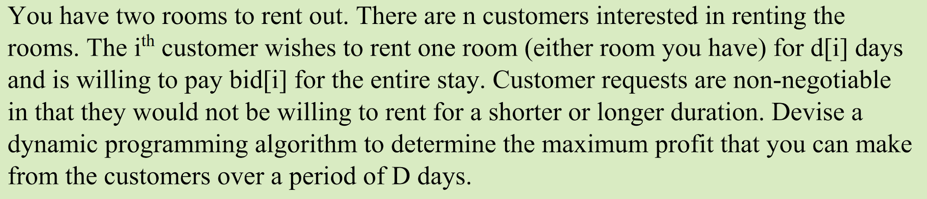

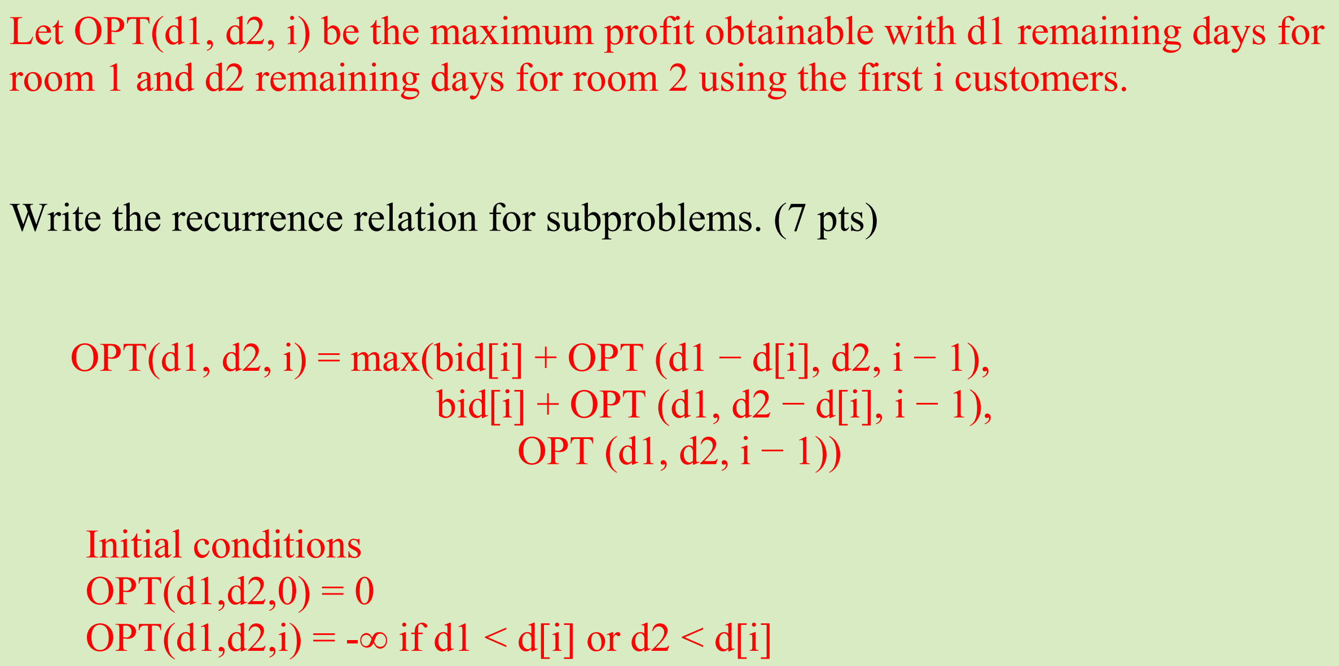

(考虑为什么为负无穷？ 因为当天数不够的时候，即便房客付再多的钱，我们都不能选择这种情况，所以要想办法让这种情况不能出现在款方案中。所以要使得opt[。。。]+bid[i] <= 0, 那只能让当前的opt[...]负无穷大)

但是有一个问题，那我直接选这个给钱巨多的不就好了吗？

**1.2 当多个限制变量不相同的时候：**

思路: 从选这个item后对各个限制变量的影响和不选这个item，这两种情况中选择最大收益来考 虑



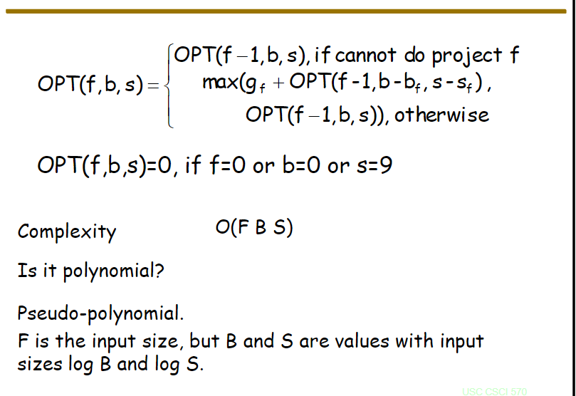

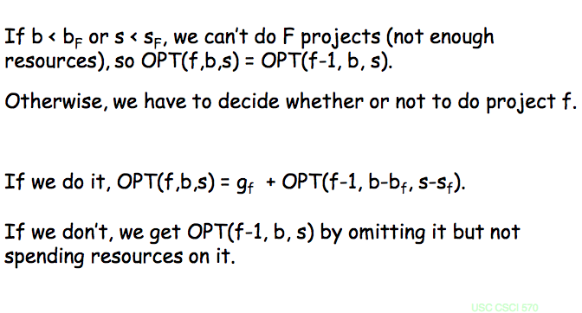

此处对limitation的处理和上道题不同，请考虑是否两种方式都可以

**1.3 自带表格问题**

Eg. 工人数量有限，要分配到不同的工厂,---与1）相比**工厂数量是变量**（有一张差异表）

Recursion formula : 注意recursion说明我不知道里层（更小的问题的solution），写表达式的时候一定是top-bottom的思路。

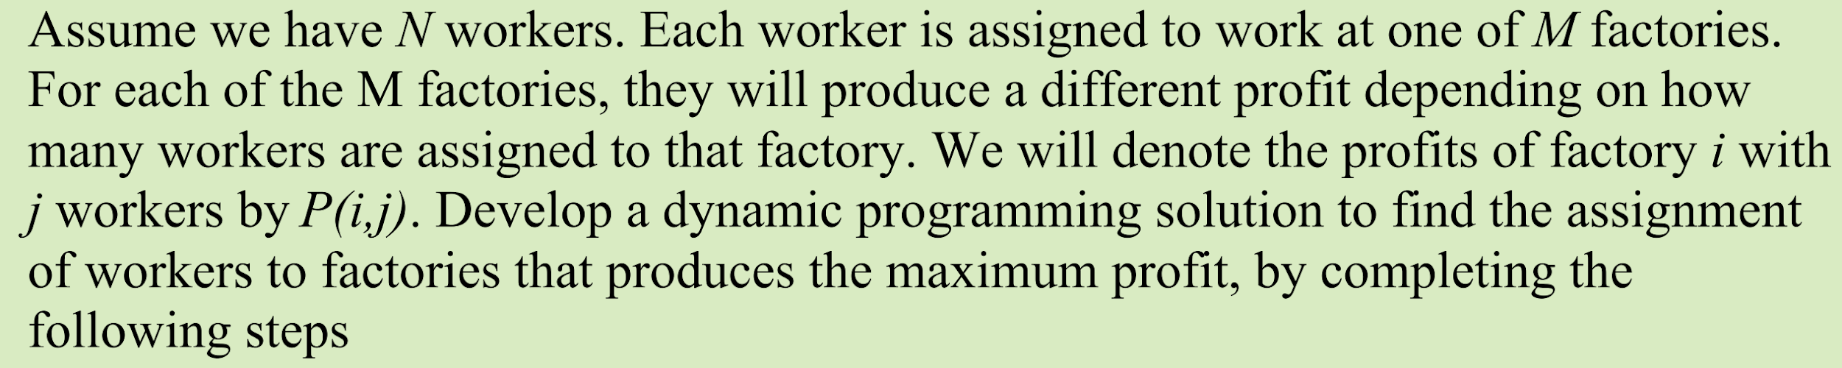

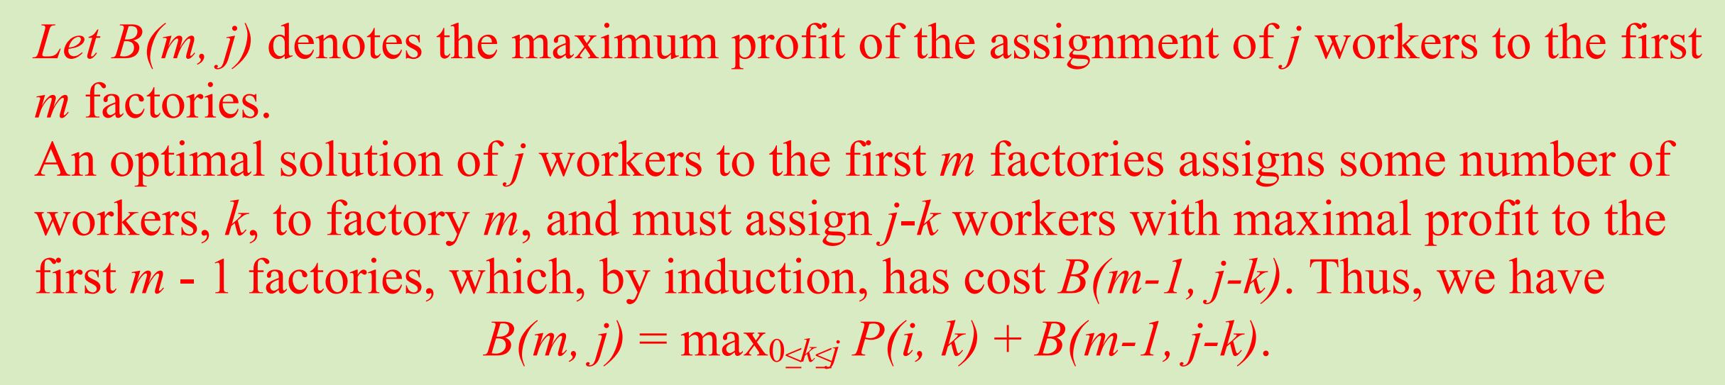

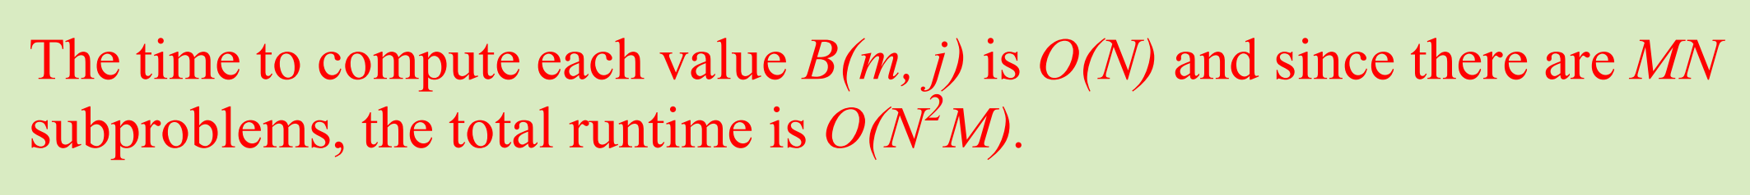

**2.断开或者分割问题：**

**这类问题分为单向伸缩和双向伸缩两大类，我们优先考虑单向伸缩（因为双向的时间复杂度会高，虽然也能解决单向伸缩问题）。如果划分的两部分都需要自己考虑每部分的最优解，那就是双向。如果另一部分的最优解题目已知，那就是单向。有的时候，两部分的结合也需要考虑cost，比如矩阵相乘，两部分矩阵相乘也有cost。**

**2.1对于单向伸缩：**

**思路：在哪切---在k处切完后，造成了两部分，然后再结合子问题的定义来写两部分分别的利润或者cost。然后再变化k，在变化中找到最大值或者最小值**

1）棒子切断销售--求最大利润

从在哪切得这个位置变量变化，来找到最大利润

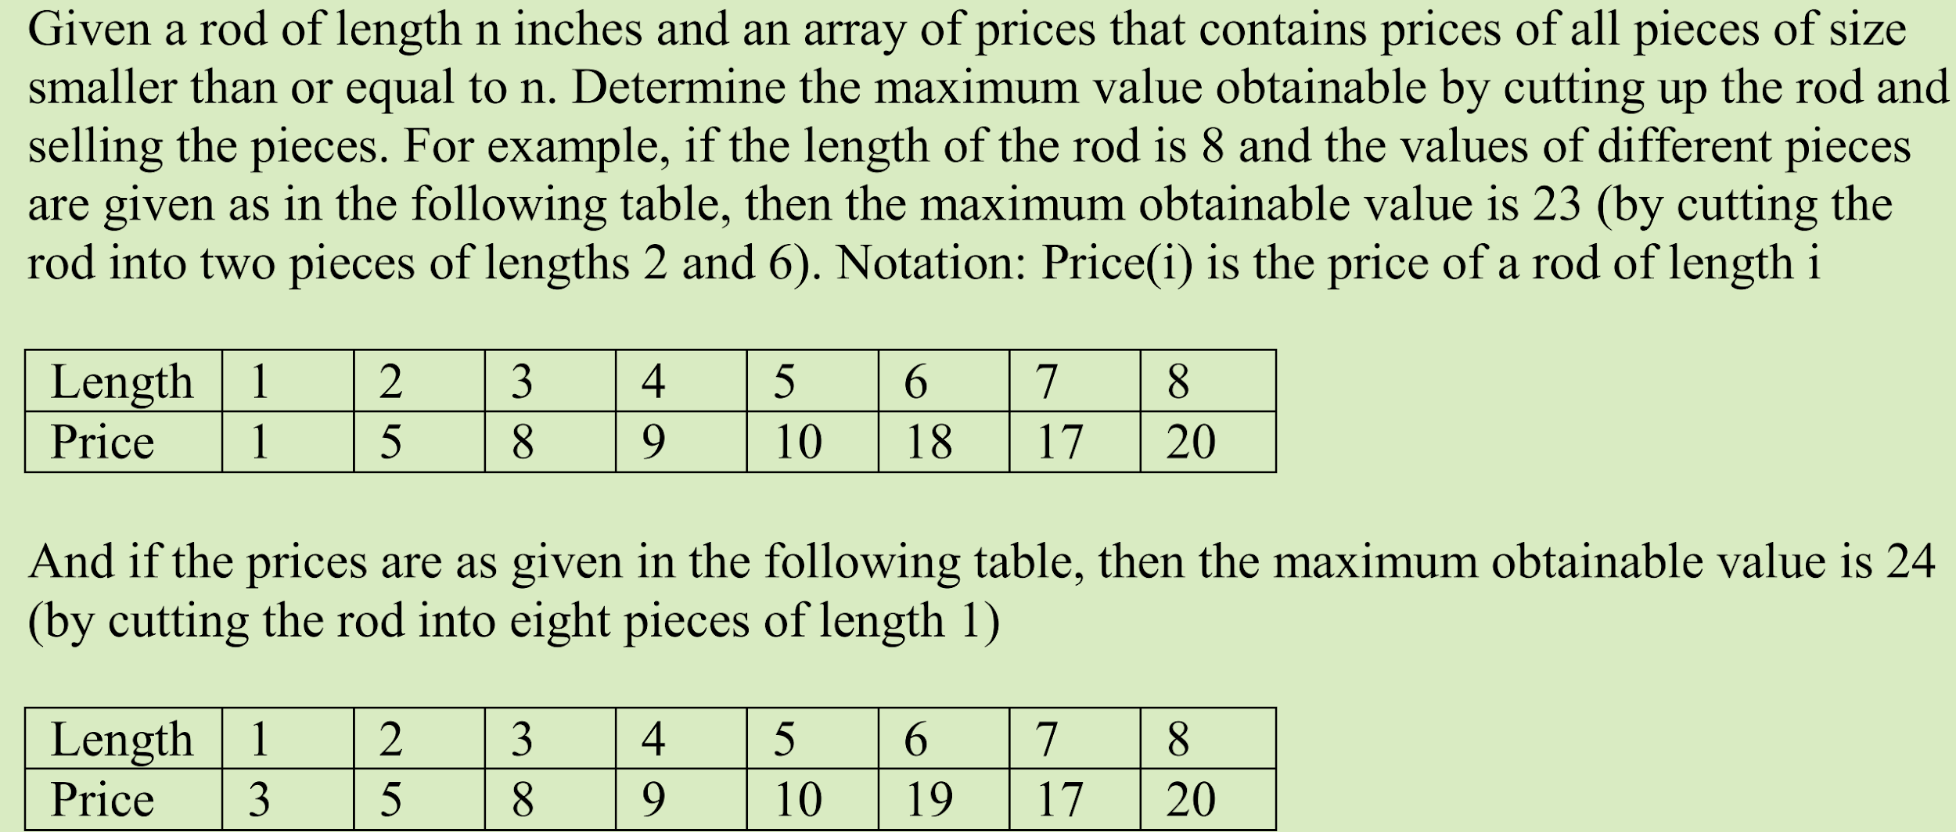

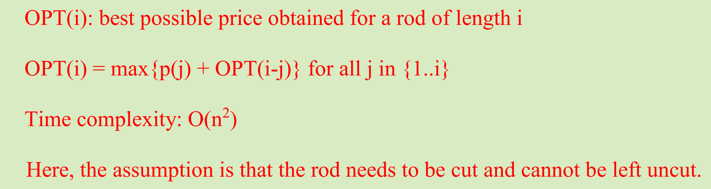

2）字符串partition——求最小cost

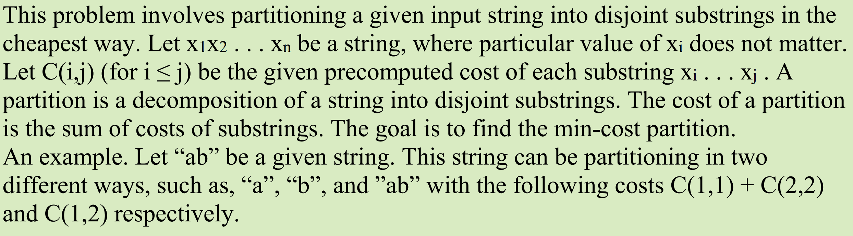

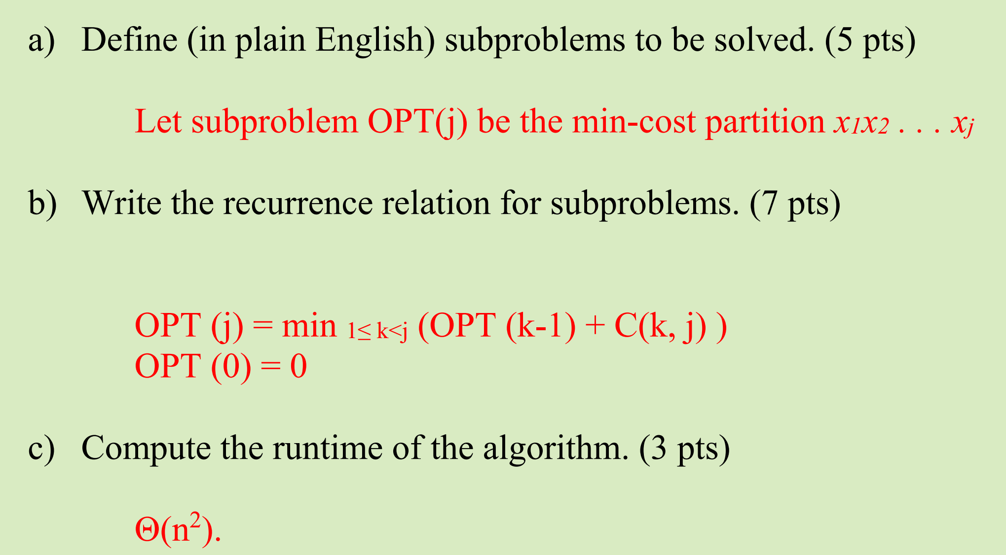

3)注意题目中隐含告诉的另一半已知问题

**只要满足了subproblem的定义，满足了对当前i的处理方式，那么就可以了。其他的我不考虑，都是在递归中实现的，这也是为什么人们觉得递归更可读**

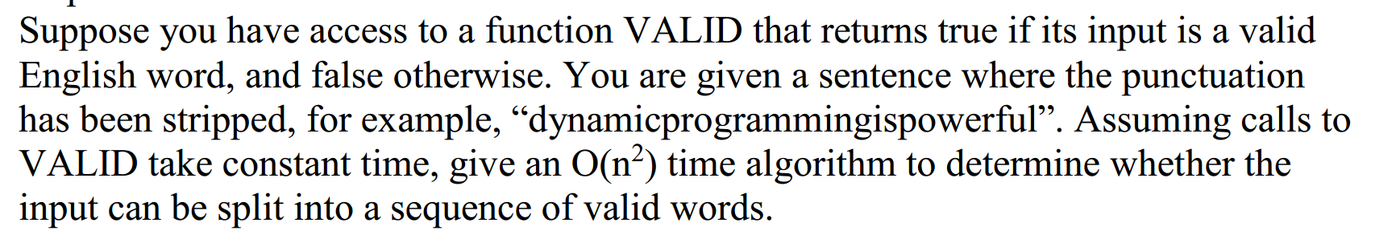

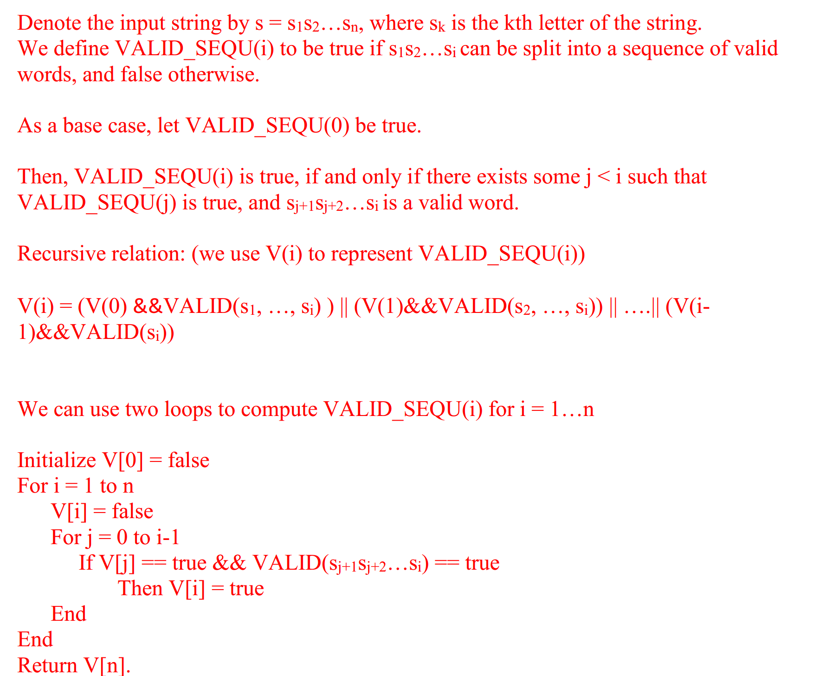

**2.2 双向伸缩问题**

**矩阵相乘：我们必须要这么做是因为，不同于单向收缩问题已经告诉另一半的cost或者profits，矩阵相乘问题的另一半的cost或者profits我们不**

**知道，也需要自己计算，所以才采用这种方法。**

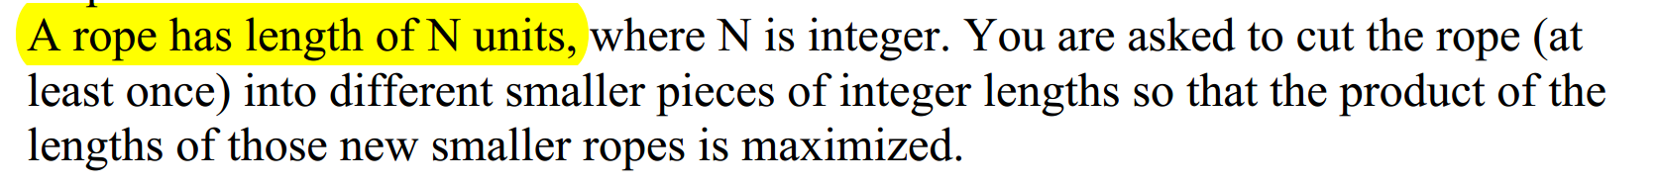

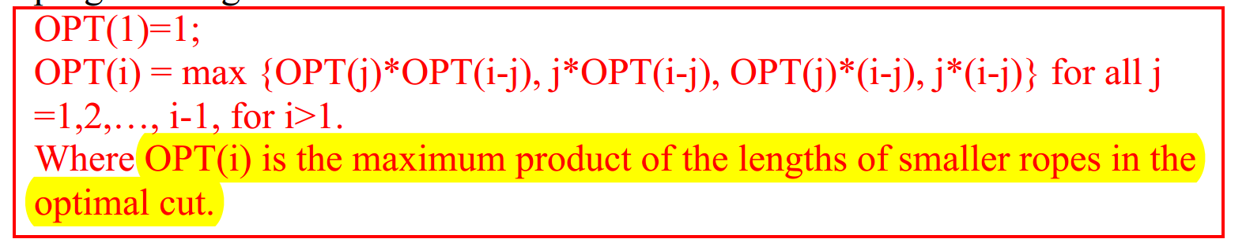

**3.背包问题扩展应用：**

**3.1 选择导致后续不能选择问题：**

**3.1.1 选择影响题目已知**

**思路：这种题型的还是遵循选和不选，但是值得注意的是这种题，因为每次选择会影响后续的选择，所以recurrence formula的书写前i个item的最优解取决于后续的选择，所以填表顺序是也是从大往小填。**

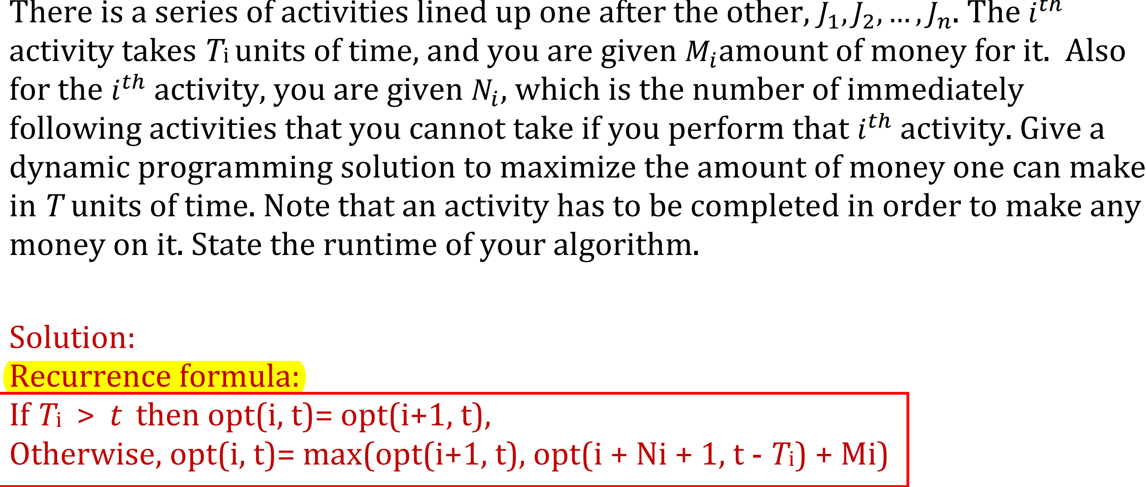

**3.1.2 选择的影响题目未知**

**解题思路：先满足我当前变量i，之后再从子问题中遍历选择最优解（具体最优解的选取不是我考虑的事情，因为题目中并没有考诉我选择的影响，所以我所要做的就是告诉你选择的时候要满足我的选择限制）**

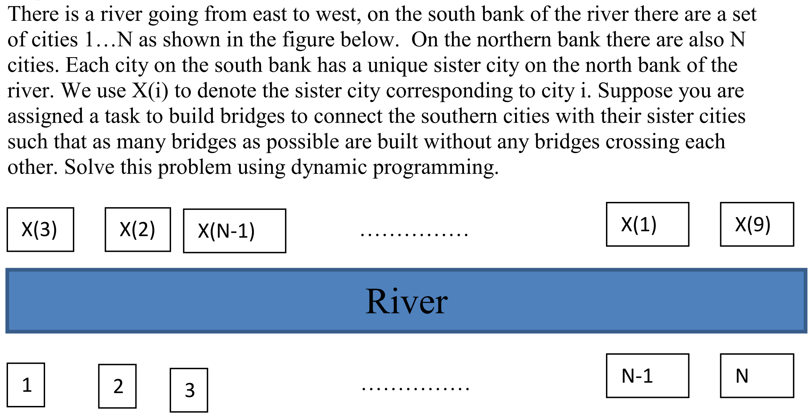

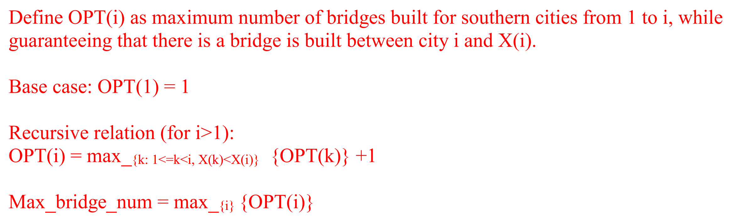

**一种思路是:先尝试（遍历比较min/max）出子问题的最优解，然后再增加子问题到当前问题的操作**

**当题目子问题最后一个的选择直接影响到整个问题的最优解时，可以定义子问题为opt[s，j]格式，即表示，到s这个容量的问题，且j是s问题最后一个元素 的最优解。如果s是无序的，recurrence formula可以考虑集合表示的方法，不一定是s-1 之类的表达更小的子问题**

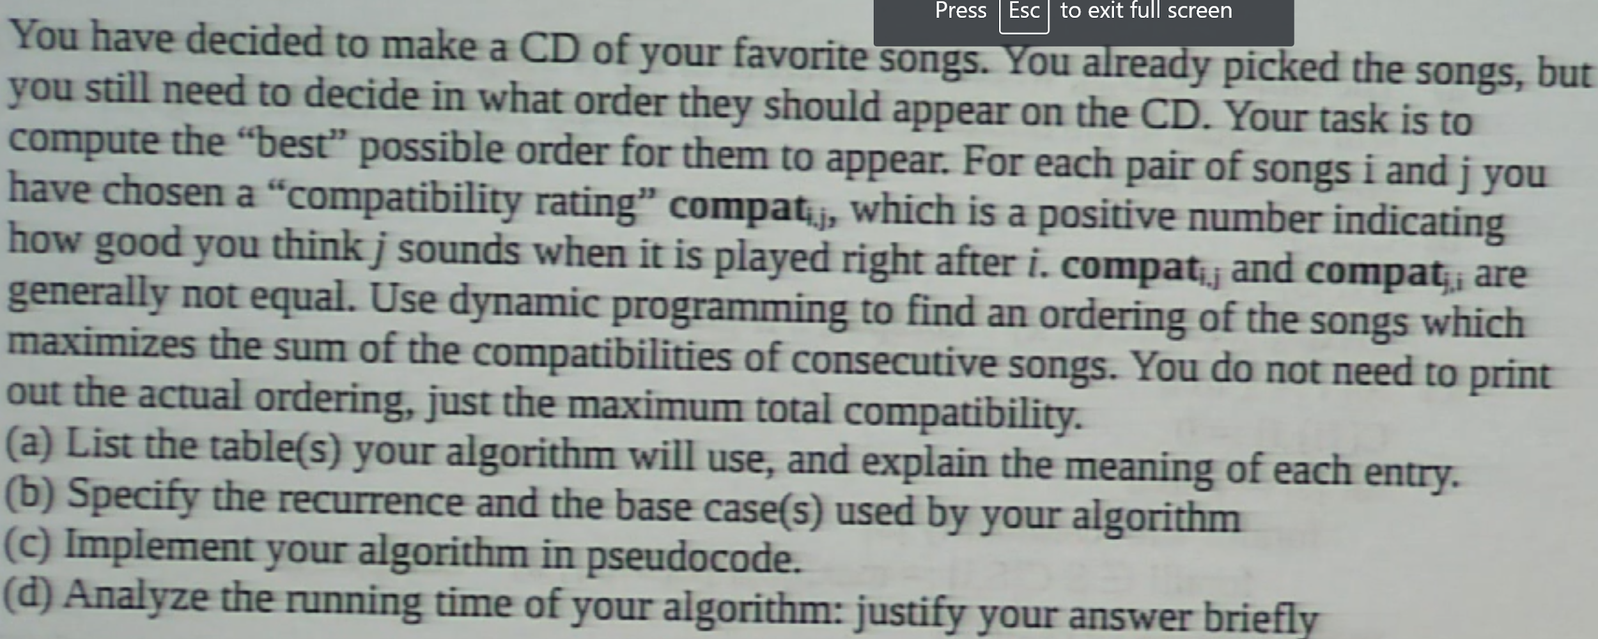



**3.2 一半相等或相近问题：**

表面上和最大最小值没有关系，但是可以把问题转成一半来研究，使得其变成背包问题来解决。

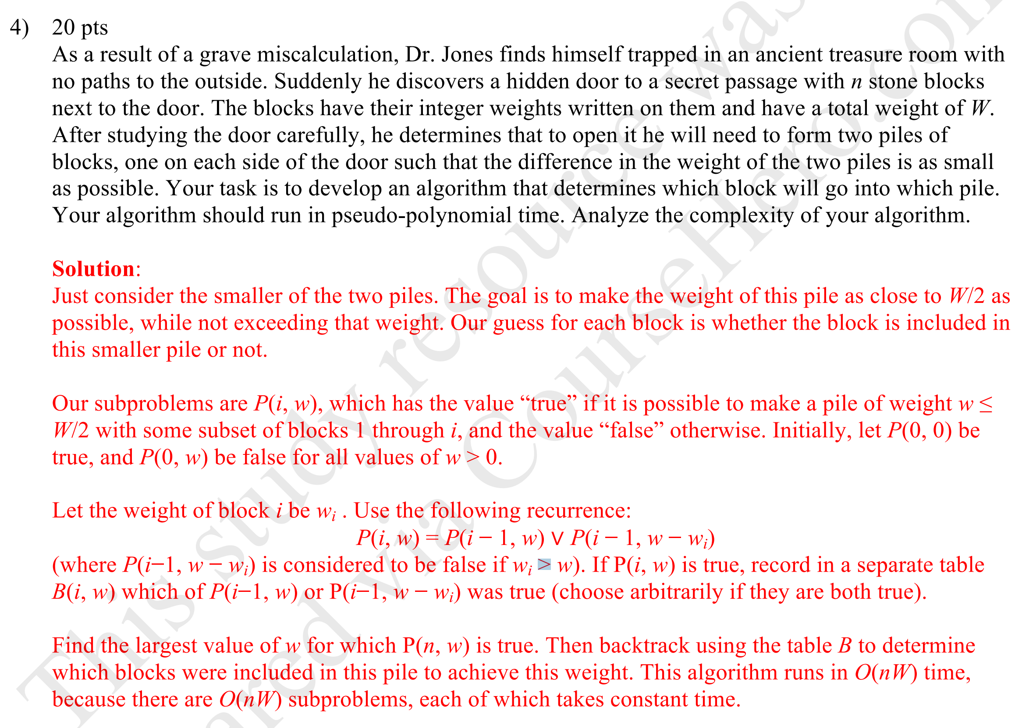

4. 寻找多少种Different ways 问题：

此类型问题根据方法的组合方式分为**有序和无序**两种情况，有序采用只看最后一位的方法来考虑（一般只有一个参数变量构造subproblem），无序采用0-1背包思想（两个变量构造subproblem）。

4.1 有序：紧盯最后的步骤，看最后一步之前形成的子问题有多少种方法

1）

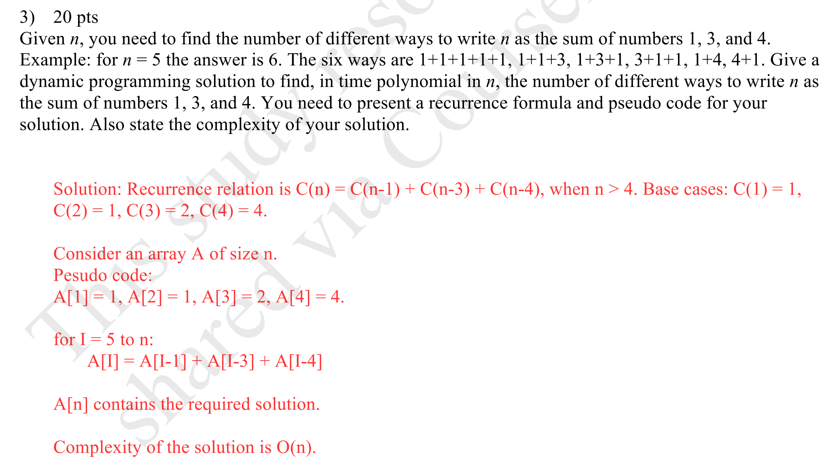

破题思路：要注意单位数不能有0，所以在考虑不同情况的时候要根据这个条件分类。

Case 1：后两位大于0且小于27 则opt[i]=opt[i-1]+opt[i-2];

Case 2：第i-1位 =0 and 第i位 ！=0 则opt[i] = opt[i-1]

Case3：第i-1 位！ =0 and 第i位=0， 则opt[]=opt[i-2]

4.2 无序问题：就看选不选这个

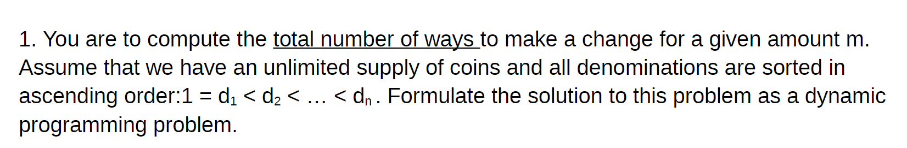

count（m,n）= count(m- dn, n) +count(m,n-1);

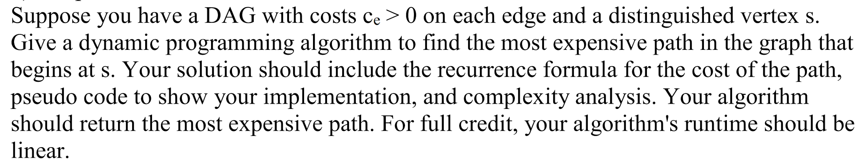

5. Backtracking 思路：

如果要知道具体的选择方法，就必须要用backtracking。backtracking的中心思路就是看opt[i]是从哪来得到的，如果需要记录选择元素的位置，我们就需要建立和opt[i]表相应的表。

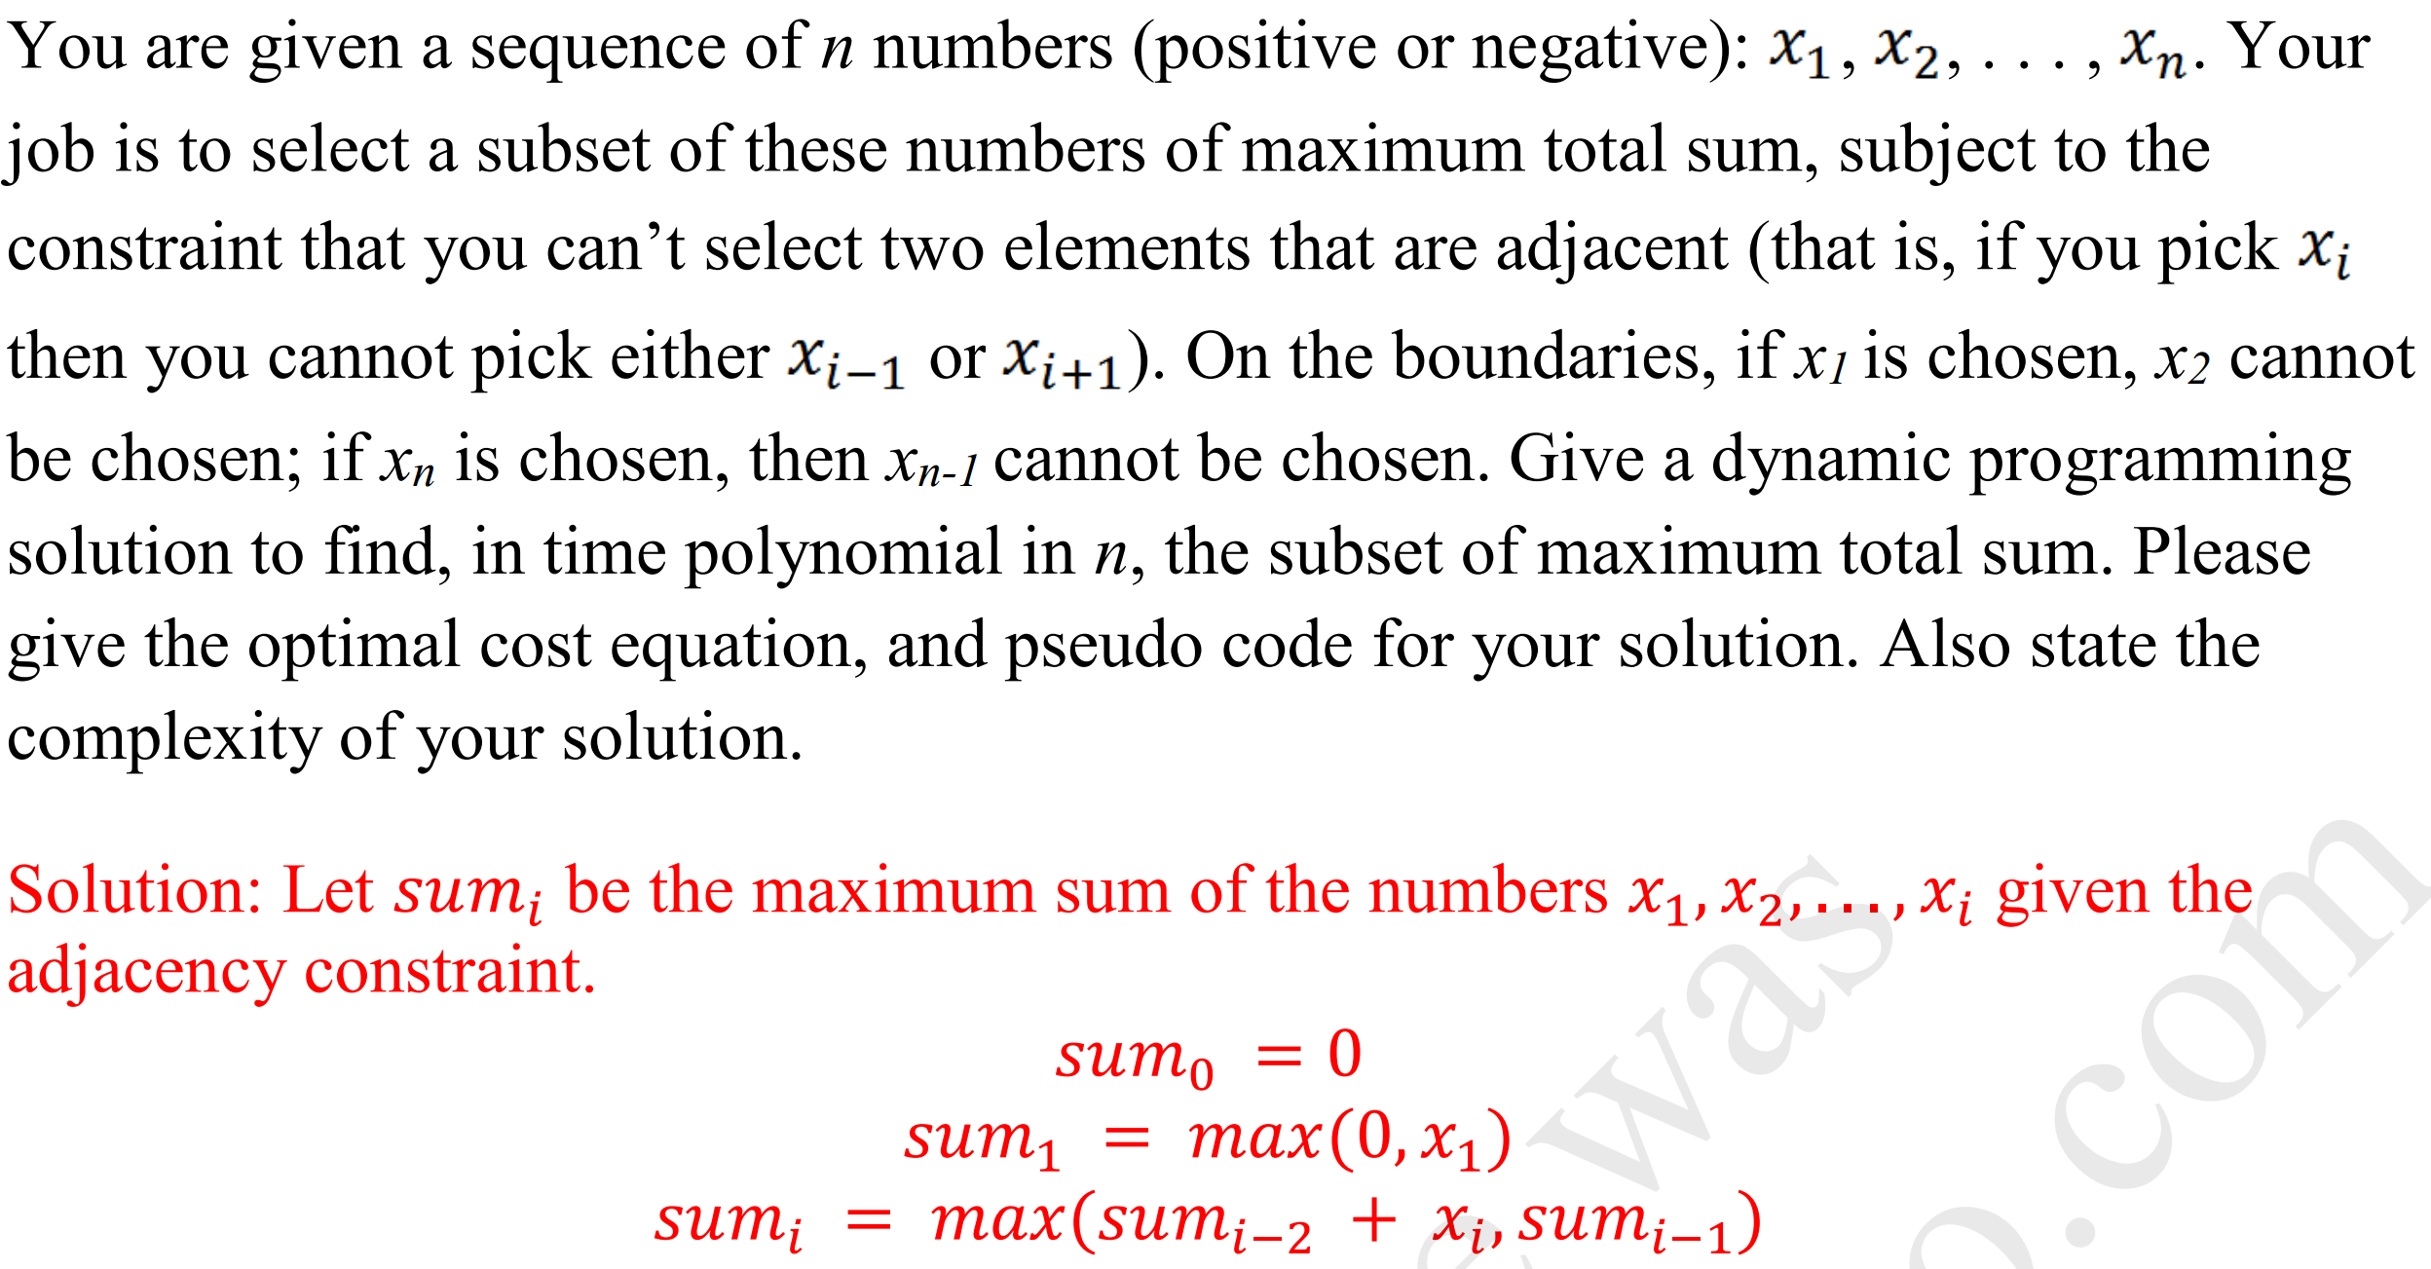

这道题需要注意的是限制条件如何影响到元素的选取！！！！

此外，比较难的经典问题还有，

“两种选择”题型：剪旗子，Alice and Bob游戏，

linear 时间找最优subarray：只考虑一头，另外一头等表格填完了可以选择出来，

需条件判断的recursion formula题型：比如光标收缩问题，LCS问题和interleaving问题

先确认尾部变量题型：color问题，拼歌曲问题，---也是集合元素排除问题，表达式中运用集合中

**排除元素的表示方法**

**总之，recursion formula 的书写：只要满足了subproblem的定义，满足了对当前i的处理方式（一定要审核），那么就可以了。其他的我不考虑，因为都是在递归中实现的，这也是为什么人们觉得递归更可读**

Network flow:

(一)概念总结：

1.min-cut 穿过的edge 都是饱满状态，edge只看out of A的。

2.min-cut穿过的edge是没有回流的(可以有回路)，因为如果存在回流的话，在G‘ 图中就会有从A*到B*的路径，这和我们对mini-cut的定义不符（也就是此时并不是mini-cut）。

3.C（A，B）=capacity of out cut(A,B)= 从A集合出去边的capacity的和（这是一个定义）

4.对于任意的s-t flow 和任意cut，我们有：v(f) = f(out A)-f(in A), 也就是说全图任意cut的净流量相同，都等于从S点当前的出流量（mini-cut只是这里的一种特殊情况）

5.我们涉及到的network要求是所有边的capacity 是integer，但是这种network的max flow也可以是非integer的，因为存在其他算法会得出非integer的max flow

6. 使用的max flow算法得出的max-flow是integer的，是因为我们每次augment的时候涉及到bottlenect，bottlenct都是integer

7.Ford-fulkerson ——O(Cm); C是从S点出来边capacity的和，实际的话是最大流的值

Scaled Ford-Fulkerson——O(${m{}_{}^{2}}^{}$ logC) weakly polynomial

Edwards-karp——O(nm^2)

8.Topological sort 用了两个stack和dfs来实现，出来的顺序是依赖关系排序的（比如，我上570，

需要先上455），时间复杂度O(V+E)

9. Min-cut 上的边是影响max flow的决定因素，即便min-cut不是唯一的。

10. Min-cut上的边不一定是bottlneck，因为可能有多个min-cut

11.所以，一旦涉及到min-cut，就要考虑是不是会还有多个min-cut

12.If all of the edge capacities in a graph are an integer multiple of n, then the value of

the maximum flow will be a multiple of n.

（二）题型总结：

解题思路：

1）仔细读题，自己组成problem的statement

2）然后考虑将题目reduce成哪种类型的model（直接max flow，有向/无向edge-disjointed，

Point-disjointed，circulation ，circulation with low bound）

3）考虑每种model需要的元素（点，edge，demand），以及他们在这个问题中的meaning

4）完成G的构建, 要一步一步得表达点由什么组成，边有什么组成，他们的值是多少

5）run max flow 算法，说明max flow 就是所求解

6）时间复杂度和必要的证明

有几层变量如何确定：

题目中固定的变量，有明确个数，或者有特定的名称或者标记的变量有几类，就有几层变量

如某类变量是不确定的，不是固定死的，那它就是波动条件

证明：

(1)证明max flow的solution 是次问题的solution

从说明满足题目中的每个限制条件来证明这个graph 满足这种限制条件

**1.对intermediate点有限制要求的问题：**

***记得比较一下下面两道题***

***是不是demand处理方式有两种情况：（1）如果对点的要求是lower bound（必须要）就是demand,需要通过连接super sink/source来转化成max-flow问题（2）如果是对点的要求是upper bound则转化为边的capacity***

***1.1 对点的要求是upper bound***

只有一组点有demand，需要把这组demand的点分身成功两个点，中间的edge就是demand

（实质：点demand可以和edge的capacity互相转化）

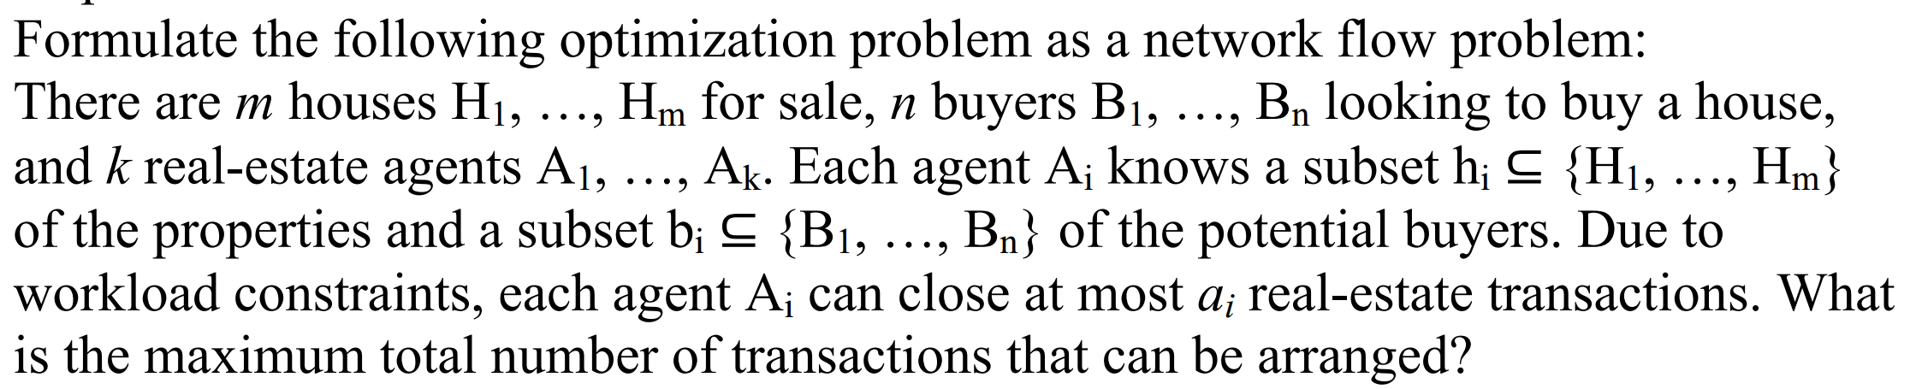

1.2 对点的要求是low bound

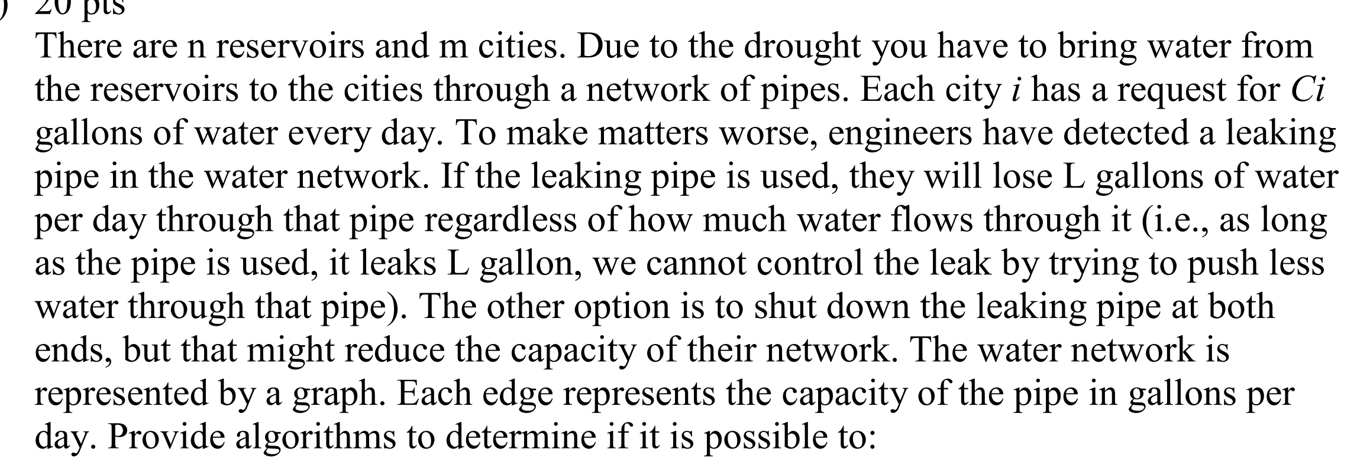

?/？？？

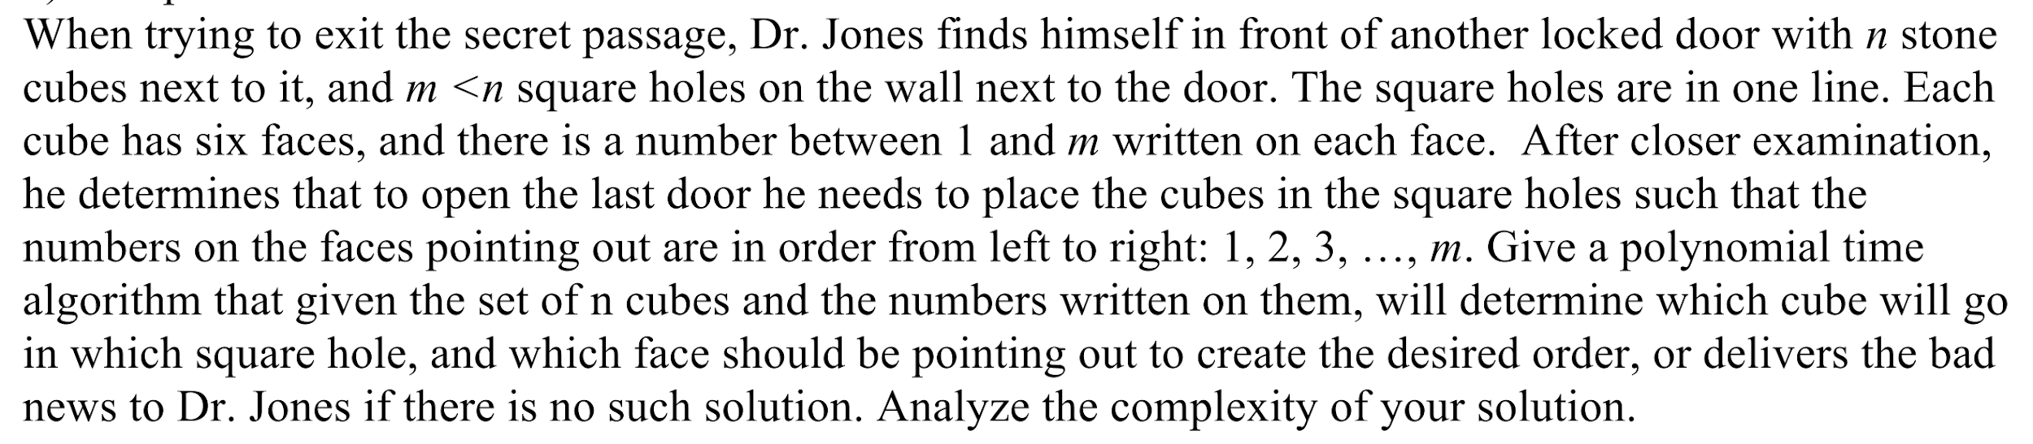

2.sink and source 有demand要求

如果有明确值的demand的要求，我们可以分别写在sink 和source 上面，也可以把他们连起来，然后加上capacity和low bound

如果没有明确的demand值的要求，我们就看可以把sink和source连起来，来后加上无限大的capacity，这样的做法会使得我们让出去的等于进去的

**3. 利用min-cut的bottleneck特性（至少也是bottleneck）来求解**

**求解有模板**

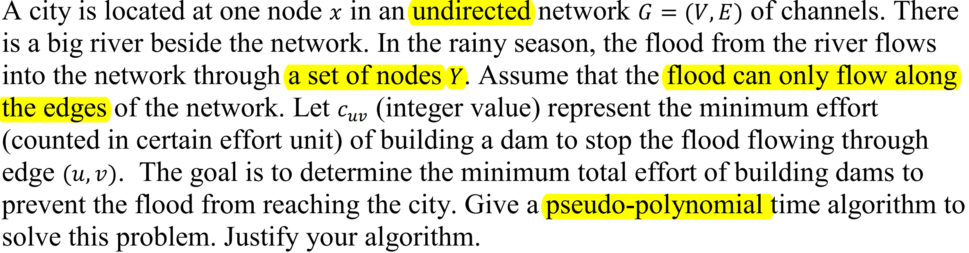

为什么能用max flow算法来直接解决“最小流问题”（不是真正意义上的最小流，最小流的特征是没有upper bound）？ 因为题目给的每条边的capacity都是最小cost，我们想做的是切断几条边，使得切断的这几条边的capacity最小，也就是说我们想要min-cut， 怎么样得到min-cut？ 当然是进行max low了

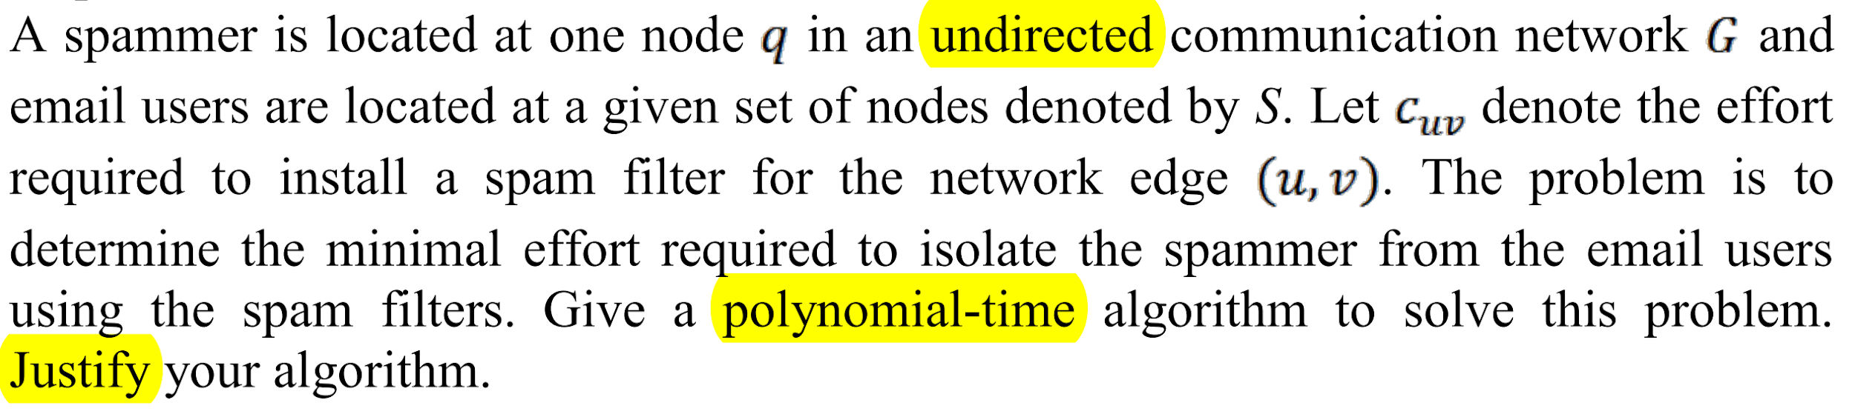

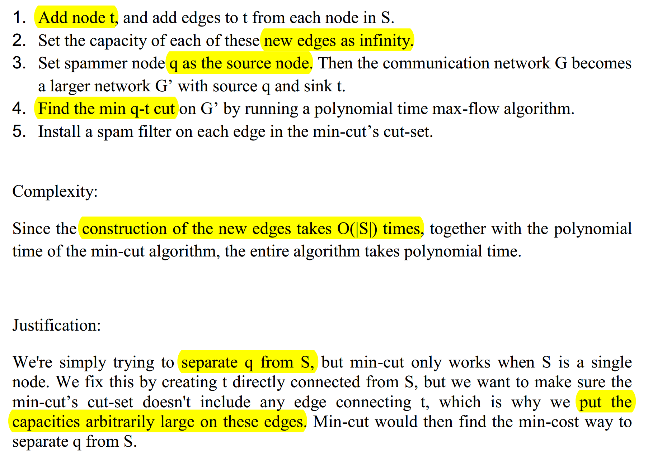

提取：如果想从一张图中把某个点分离出来，我们就需要用到min-cut，但是min-cut只能分开两个独立的单元，所以此时我们就想办法吧我们想分离的量部分抽象成两个独立单元，比如添加sink或者source

（四）典型问题的时间复杂度汇总：

Money change：O（mn）

knapsnack：O（Wn）

Binary search tree：O(n^3)

LCS:O(nm)

Floyd-Warshall algorithm: O(v^3)

Chain matrix multiplication: O(n^3)

**曹明凯：**

1. **Divide & Conquer:** <https://workflowy.com/s/HdnT.nGF8nwvDcd>
2. **DP：**<https://workflowy.com/s/HdnT.JuSQSMKgWb>
3. **Network Flow:** <https://workflowy.com/s/HdnT.BrgfX4QtKq>
4. **Shortest Path on DAG in O(E+V):** <http://www.stoimen.com/blog/2012/10/28/computer-algorithms-shortest-path-in-a-directed-acyclic-graph/>
5. **P-NP-NPC:** [**https://workflowy.com/s/HdnT.aW8rmXxxBA**](https://workflowy.com/s/HdnT.aW8rmXxxBA)

**费炜**

**Chapter 6 - Dynamic Programming**

**General Definition of DP**

* Difference between DP & DC: DP is applicable when the subproblems are overlap, so DC does not count as DP.
* Basic steps of Dp:
  + Define subproblems
  + Write the recurrence relation
  + Construct the solution in bottom-up way
  + Computer its runtime complexity

**Fibonacci Sequence**

* Worst case recurrence: T(n) = T(n-1) + T(n-2) + O(n) = O(2^n).
* Memoization (top-down, recursion): T(n) = T(n-1) + O(n) = O(n^2).
* Tabulation (bottom-up, iteration).

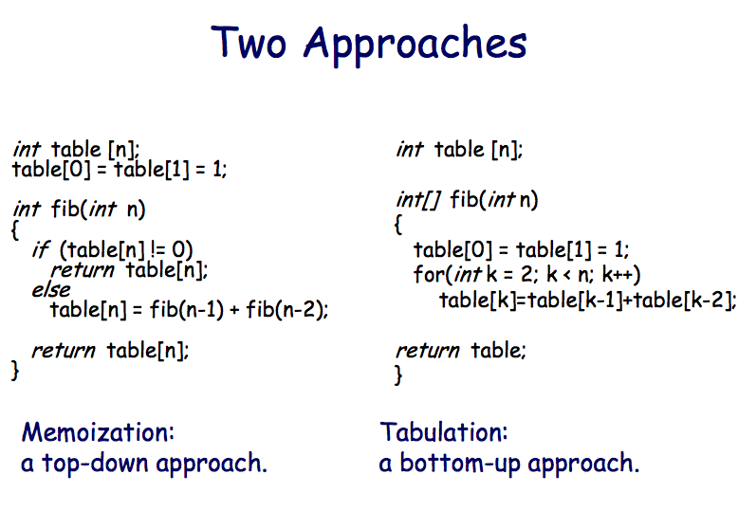

**Coin Changing Problem**

* Subproblems: c[k, x] is the least number of coins represent some amount x (0 <= x <= m using first k (1<= k <= n) denominations.
* Recurrence relation:
  + c[k, x] = MIN (1 + c[k, x – dk], c[k - 1, x ])
  + c[k, x] = c[k - 1, x ], if x < dk
  + c[k, 0] = 0
  + c[1, x] = x
  + where 1 <= k <= n and 0<= x <= m
* Complexity: O(nm), which is defined by a table size times the work we do in each table cell.

**0-1 Knapsack Problem**

* Running time of the brute force approach: O(2^n).
* Subproblems: OPT[k, w] is the maximum value achievable using a knapsack of capacity 0 ≤ w ≤ W and with k items 1 ≤ k ≤ n.
* Recurrence relation (assume all items are unique):
  + 1) Xk = 1, item k is included: OPT[k, W] = Vk + OPT[k-1, W - Wk]
  + 2) Xk = 0, item k is not included: OPT[k, W] = OPT[k-1, W]
  + OPT[k, W] = MAX(Vk + OPT[k-1, W - Wk], OPT[k-1, W])
  + OPT[k, W] = OPT[k-1, W], if Wk > W
  + OPT[k, W] = 0, if k = 0 or W = 0
* Complexity: O(n+1)*(W+1) = O(nW)
  + The total input size is O(n(logW + logV)).
  + The actual complexity is **T = O(n*2^(input size of W))**, which is **psudo-polynomial**. So if we change W by one bit, the amount of work (the table size) will double.

**Optimal Binary Search Tree**

* Running time of the brute force approach: O(4^n).
* Expected cost for binary search tree = Sum<i = 1 to n>( pi * depth(Ki) ).
* Optimal BST may not have the smallest height and may not have highest-probability key at the root.
* Subproblems: OPT[i, j] is the optimal cost for ki, … , kj. Choosing kr as the root, we compute the cost of this tree T directly.
* Recurrence relation:
  + OPT[i, j] = Cost(T) = 1*Pr + Sum<s = i to r-1>(Ps * depthT(Ks) ) + Sum<s = r+1 to j>(Ps * depthT(Ks) )

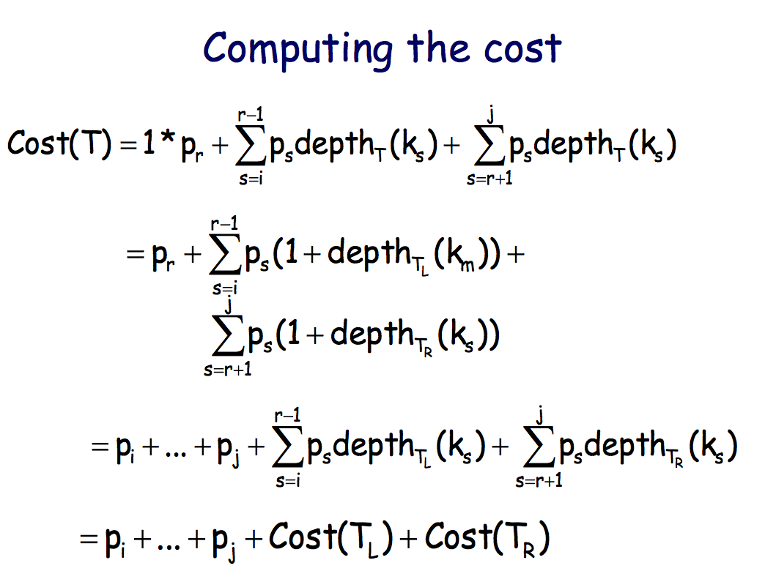

* + OPT[i, j] = min(1<=r<=j)(OPT[i, r-1] + OPT[r+1, j]) + pi + ... + pj
  + OPT[i, i] = pi, for 1 <= i <= m
  + OPT[i, i-1] = 0, for 1 <= i <= n
* Complexity: O(n^3) with table size O(n^2) and each iteration O(n)

**Longest Common Subsequence**

* Subproblems: LCS[i, j] is the length of the LCS of S[1…i] with T[1…j]
* Recurrence relation:
  + S[i] = T[j]: LCS[i, j] = 1 + LCS[i-1, j-1]
  + S[i] ≠ T[j]: LCS[i, j] = max(LCS[i-1, j], LCS[i, j-1])
  + LCS[i, 0] = LCS[0, j] = 0
* Complexity: O(nm)

**The Bellman-Ford Algorithm**

* Goal: Consider the path v = w0, w1, …, wk−1, wk = u.To have an optimal substructure the following path v = w0, w1, …, wk−1 must be a shortest path to wk−1. Thus, we will be counting the number of edges in the shortest path. This is how we order subproblems.
* Subproblems: D[v, k] denotes the length of the shortest path from s to v that uses at most k edges.
* Recurrence relation:
  + D[v, k] = 0, if k = 0 and v = s
  + D[v, k] = infinite, if k 0 and v != s
  + D[v, k] = min(D[v, k-1], min(D[w, k-1] + c(w,v) ))
* Implementation:

*for k=1 to V-1:*

*for each v in V:*

*for each edge (w,v) ∈ E*

*D[v, k] = min(D[v, k-1], c(w, v) + D[w, k-1])*

* Complexity: **O(VE)**. Because 2 nested loops equivalent to doing it for every edge (the 2nd and 3rd loops).
* Apply the algorithm to find out if a graph has a **negative cycle**: do not stop after V-1 iteration, perform one more round. If there is such a cycle, then if anything changes in the table, we know there is a negative cycle.

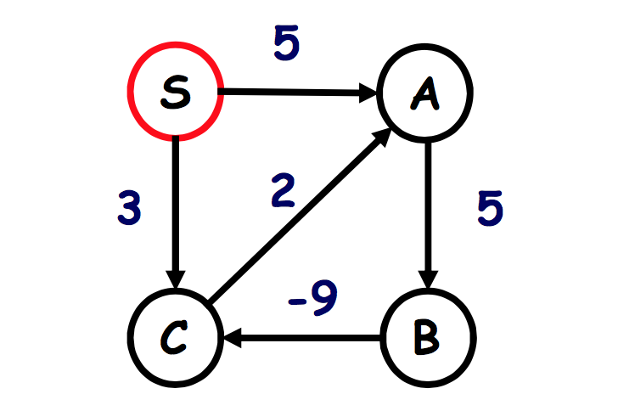

* For example, in this graph, min(S->A) should be 5. However, if we run one more round, [A, 4] = 3 when k = 4.

**The Floyd-Warshall Algorithm**

* Goal: given a graph G with weighted edges (weights may be positive or negative), find the shortest path between each pair of vertices.
* Subproblems: Let D[i, j, k] be the shortest path from i to j for which all intermediate vertices can only be chosen from the set {1,2,..., k}. A shortest path does not contain the same vertex more than once**.**
* Recurrence relation:
  + D[i, j, k] = min(u)(D[i, u, k-1]+D[u, j, k-1], D[i, j, k-1]) //Since the optimal path for D[i, j, k] may or may not have u as an intermediate node
  + D[i, j, 0] = c(i, j)
  + D[i, i, 0] = 0
* Implementation:

*for k=1 to V:*

*for i=1 to V:*

*for j=1 to V:*

*D[i, j, k] = min(D[i,j,k-1],* *D[i,k,k-1] + D[k,j,k-1])*

* Complexity: **O(VEV)**
* Apply the algorithm to find out if a graph has a **negative cycle**: at the end of each iteration of the outer loop, we check the value of D[i,i,k] for all i. If any of these are negative, then a negative cycle has been found.
* To extract the shortest path: (backtracking) we need to create the new matrix P[i,j] in addition to the matrix of distances. Whenever we discover that the shortest path from i to j passes through an intermediate vertex k , we set P[i,j] = k. P[i,j] = 0 if it’s the edge (i,j).

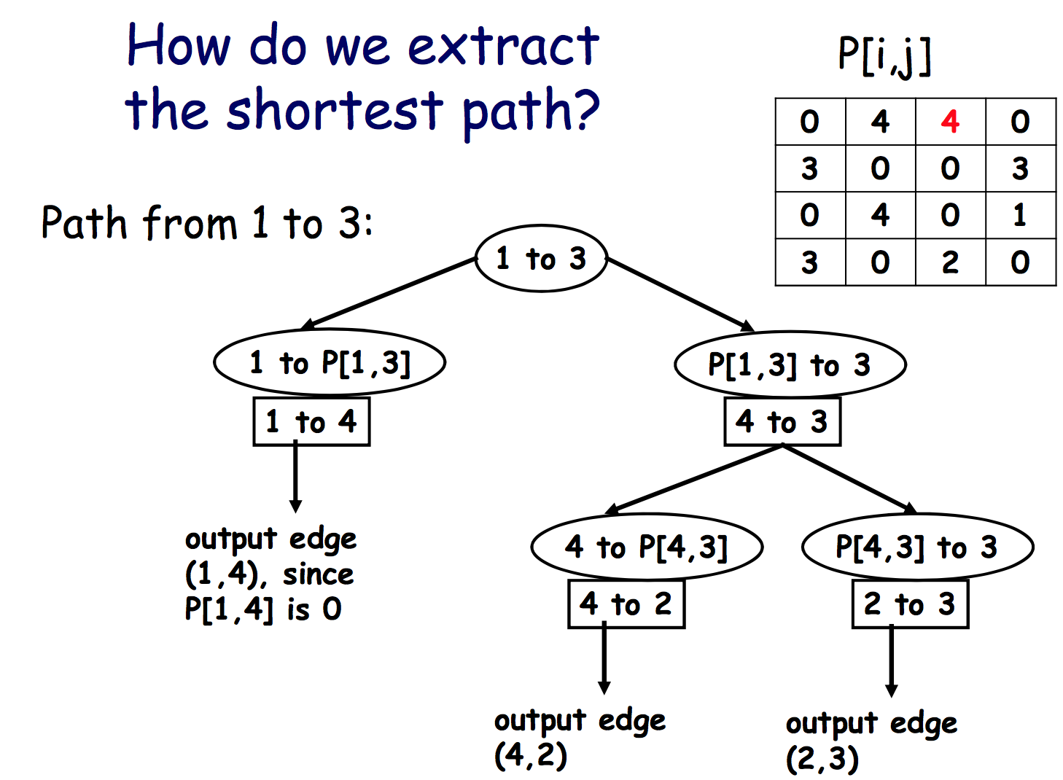

**Matrix Multiplication**

* Goal: we want to know the best order in which to perform multiplications of more than 2 metrics.
* Subproblems: Opt[i, j] = min cost of Mi*Mi+1*…*Mj.
* Recurrence relation:
  + Opt[i, j] = MIN(i≤k<j)(Opt[i, k] + Opt[k+1, j] + r(i-1) * r(k) * r(j) )
  + Opt[i, i] = 0
  + where 1 ≤ i < j ≤ n
* Implementation:

Set Opt[i, i]= 0 for all i = 1, ..., n.

for(s = 1; s < n; s++)

for(i = 1; i <= n-s, i++)

j = i + s;

Opt[i,j] = min(i ≤ k < j)(Opt[i,k]+Opt[k+1,j] + r[i-1]*r[k]*r[j]);

return Opt[1,n]

* Complexity: O(n^3). Because table size is O(n^2), and cost per entry is O(n).

**Polygon Triangulation**

* Goal: give a DP algorithm for triangulating a convex polygonwith n vertices while minimizing the total perimeter of allthe triangles.
* Subproblems: OPT[i, j] denote the minimum weight triangulationfor the subpolygon (i, i+1, ..., j-1, j) where 1 ≤ i < j ≤ n.
* Recurrence relation:
  + OPT[i, j] = min (i<k<j)(OPT[i,k] + OPT[k,j] + perimeter)
  + OPT[i, i] = OPT[i ,i+1] = 0
* Complexity: O(n^3). Similar to matrix multiplication.

**Chapter 7 - Network Flow**

**Overall Strategy to Find Max Flow**

* Find a path from s to t.
* Find the bottleneck value for this path.
* Push flow through this path with value equal to bottleneck value.
* Repeat.

**Pseudocode of Finding Max Flow**

* Augment step:

*Augment (f, c, p)*

*let b = bottleneck (p)*

*for each edge (v, u) belongs to P*

*if e = (v, u) is a forward edge:*

*then increase f(e) by b*

*else if (v, u) is a backward edge, and let e = (u,v):*

*then decrease f(e) by b*

*end if*

*end for*

* Ford-Fulkerson algorithm:

*Max Flow (G, S, T, C)*

*initially f(e) = 0 for all e in G*

*while there is an s-t path in Gf*

*let P be a simple s-t path in Gf*  ***//O(m)***

*f` = augment (f, c, p)*  ***//O(n)***

*f = f`*

*update Gf*  ***//O(n)***

*end while*

*return f*

* Complexity: **O(Cm)**, that is **O(2^(log2C) * m)** - pseudo-polynomial

**Key Points of Proof**

* While loop termination:
  + V(f) = Sum(e out of s) of f(e) <= Sum(e out of s) Ce = C.
  + The loop terminates after at most C iteration (assume each iteration only flow 1, which is the minimum integer unit).
* F is a a max flow:
  + Define a cut: a cut divides nodes in the graph into 2 sets A&B such that s belongs to A and t belongs to B.
  + flow and (A,B) be any s-t cut, then: V(f) = f(out)(A) - f(in)(A).

**Import Claims**

* Let f be any s-t flow, and (A, B) be any s-t cut. Then v(f) = f(out)(A) - f(in)(A).
* Let f be any s-t flow, and (A, B) be any s-t cut. Then v(f) <= c(A, B).

**Min Cut**

* If val( f) = cap(A, B), then f is a max flow and (A, B) is a min cut.
* The min cut in a graph does not have to be unique.
* How to determine if a min-cut is unique
  + Reverse all the edges on the residual graph, and then find another min-cut again.
  + If they are same, then it is unique; otherwise, not unique.

**Augment Optimization**

* Set “delta" to be the largest power of 2 that is no larger than the max. capacity out of S
* Codes:

Max Flow (G, S, T, C)

initially f(e) = 0 for all e in G

Set # to be the largest power of 2, that is no larger than the Max, cap out of S

**while delta >= 1** //log2C iterations

while there is an s-t path in Gf

let P be a simple s-t path in Gf

f` = augment (f, c, p)

f = f`

update Gf

end while

**delta = delta / 2**

end while

return f

* Explanation: we need to set up #, and then take out all edges smaller than “delta". Next, we will run Ford-Fulkerson algorithm for the graph with min edge = “delta".
* During the delta-scaling phase, each augmentation increases the flow value by at least #.
* Claim: Let f be the flow at the end of the delta-scaling phase, then therein an s-t cut (A,B) in G for which C(A,B) <= v(f) + m*delta

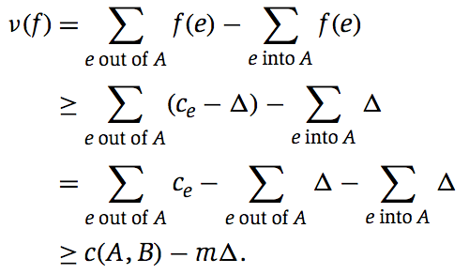

* Claim: the number of augmentations in a scaling phase is at most 2m.
* An algorithm runs in strongly polynomial time if the number of operations is bounded by a polynomial in the number of **integers** in the input.
* Complexity: **O (m^2 * logC)** - Weakly polynomial since logC is bounded by number of bits, but not number of integer.

**Edmonds-Karp**

* Same as For-Fulkson, except that each augmenting path must be shortest path with variable capacity (minimum number of edges)
* Complexity: **O(n*m^2)** - Strongly polynomial

**Bipartite Matching**

* We put 1 between start point and any points in bipartite graph because we want to force the constrains that only one edge will be used for out flow on the point of bipartite graph.
* Proof template of problem reduction:
  + If we have an s-t flow of value k in G`, we can find a matching of size k in G:

1. Make a cut on the middle of the graph G`, which across the bipartite matching. Then it should be k edges carry the flow.
2. Since the capacity of the edges from source and into the sink is only , the edge carry flow does not share any start node or end node of edges in G with other edges.
3. So there should be a unique path for each edge in G.

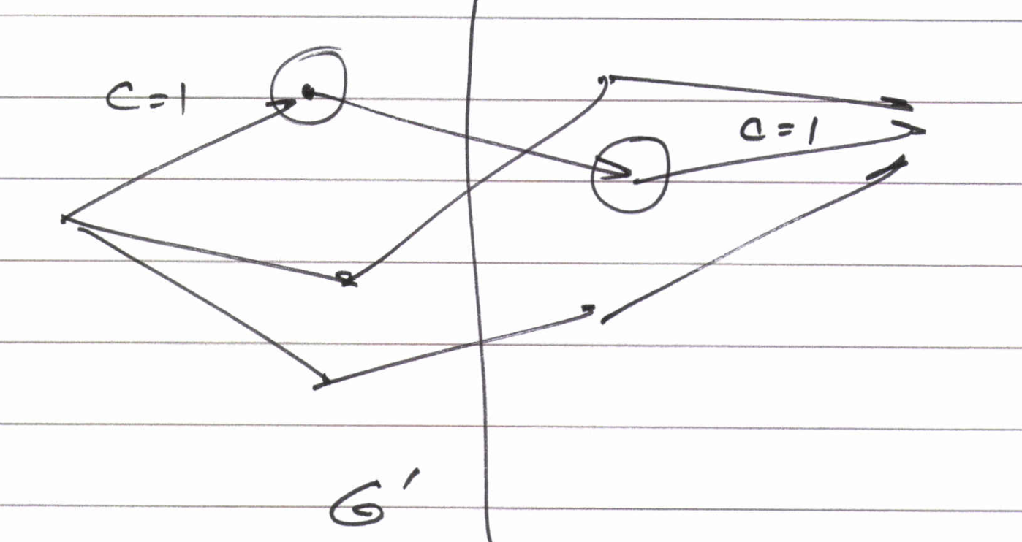

* If we have a matching of size k in G, we can find an s-t flow of value k in G`:

1. The nodes in G are all independent, which not share with each other.
2. So each edge can carry the flow on every path independently.

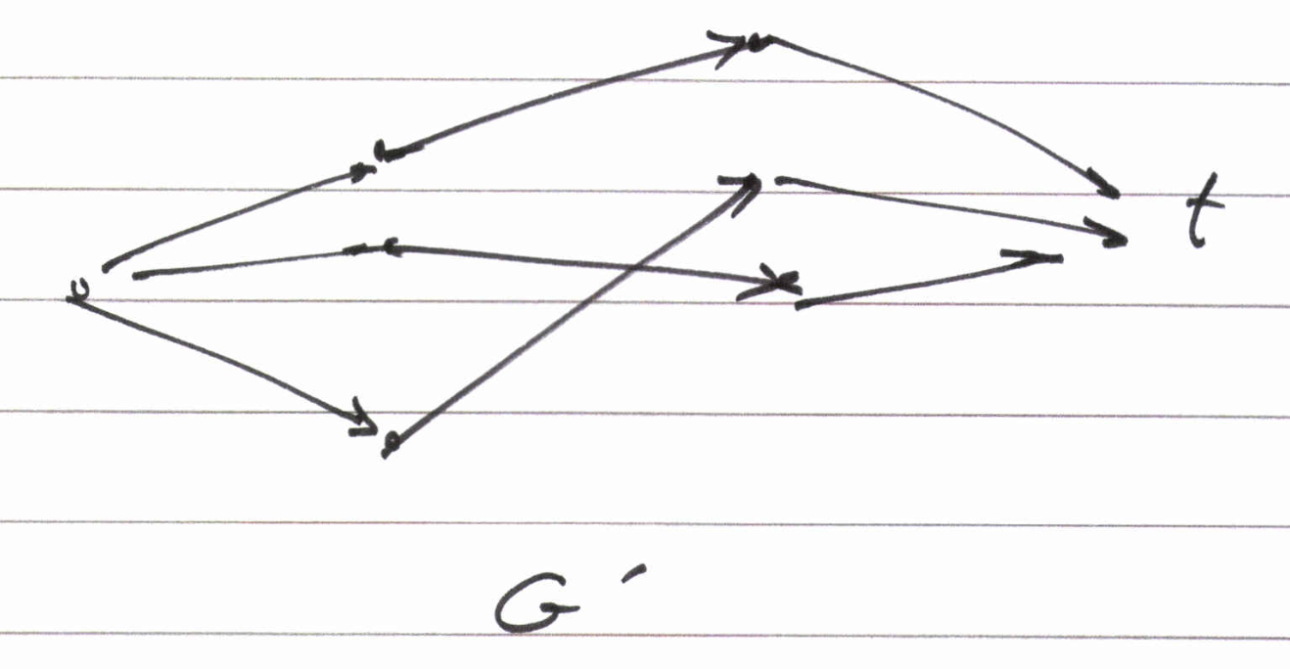

* Theorem: max cardinality of a matching in G = value of max flow in G`.
* We use Ford-Fulkson to solve the underlying max flow problem, then the complexity is O(Cm) = O(nm) since there are at most n edges with cap = 1. It is strongly polynomial.

**Disjoint Path**

* Def: A set of paths are edge-disjoint if their edge sets are disjoint. Or two paths are edge-disjoint if they have no edge in common.
* Theorem: max number of edge-disjoint s-t paths = value of max flow.
* Proof of correctness:
  + If we have k edge disjoint s-t paths in G, we can find a flow of value k in G` (Same as above).
  + If we have a flow of value k in G`, we can find k edge-disjoint s-t path in G.

1. Since k is greater than 0, we can at least find a path A start from point S, and trace through G, goes into the T.
2. Take out all edges from path A, and find the second path from S if k is greater than 1, until find all paths from S to T.
3. Once we repeat the steps k times, we will find k paths from S to T. These edges should be disjoint because we eliminate each edge before finding next edge.

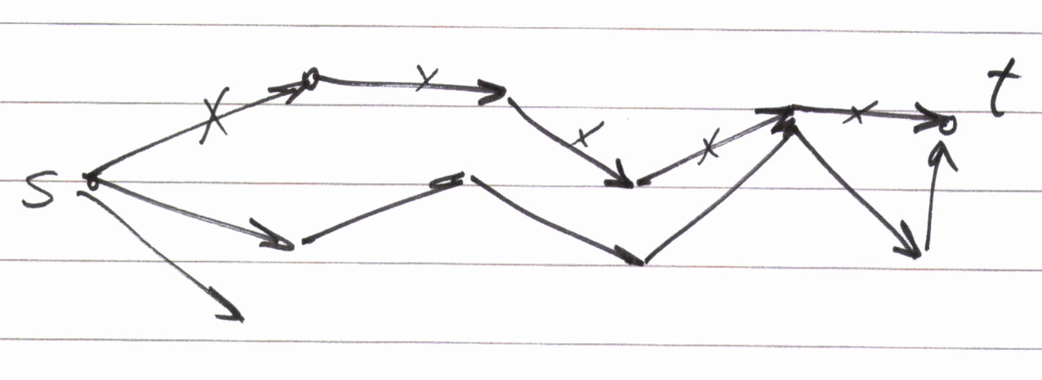

**Node-disjoint Path**

* Def: a set of paths is node-disjoint if their node sets (except for starting & ending nodes) are disjoint.
* Design strategy: set each node V other than S&T into 2 nodes V` that connected to all incoming edges and V`` that connected to all outgoing edges:

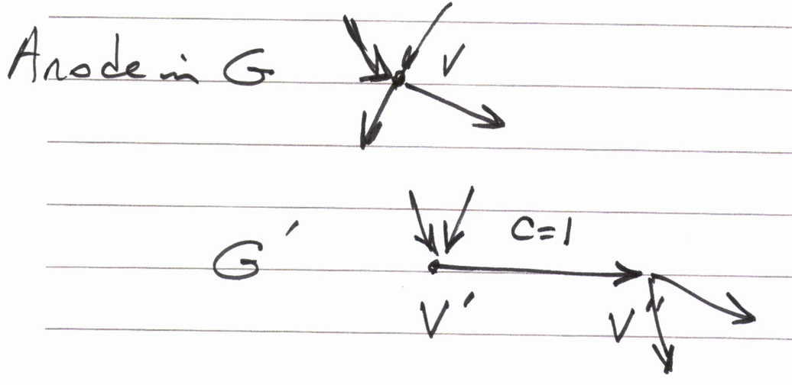

After constructing G`, we run max flow on G`.

**Circulation Network**

* Def: given a directed graph G = (V, E) with capacities on the edges. Associated with each node v∈V is a demand dv
  + If dv > 0, node v has demand of dv for flow (sink)
  + If dv < 0, node v has a supply of |dv| for flow (source)
  + If dv = 0, v is either a sink nor a source
* Def: a circulation with demand {dv} is a function f that assigns non-negative real number to each edge and satisfies:
  + Capacity condition: for each edge e∈E, 0 ≤ f(e) ≤ Ce
  + Demand condition: for each node v∈V, f(in)(v) - f(out)(v) = dv
* Fact: if there is a feasible circulation with demands {dv}, then Sum (dv) = 0
* The way to solve demanding problem: add a super source to connect all sources (nodes with dv < 0) and a super sink to connect all sinks (dv > 0). Then run max flow algorithm to find the max flow x.
  + If x < D => no feasible circulation in G
  + If x > D => not possible
  + If x = D => feasible circulation in G

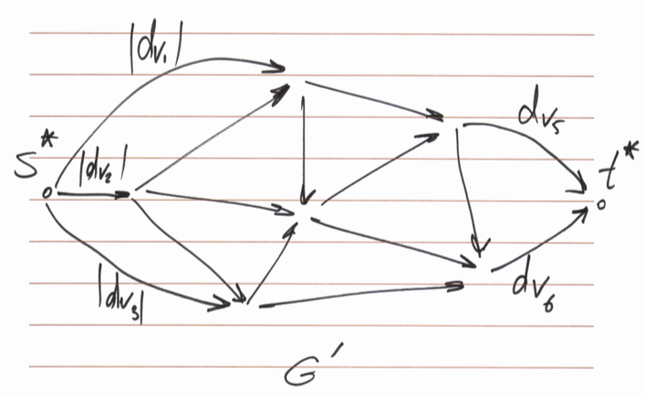

* Proof of correctness:
  + If there is a feasible circulation f with demand values {dv} in G, we can find a max flow in G` of value D.

1. Remove supply values, and replace all supply values |dv| to the capacity of each edges with exact same value, do the same things on the demand values as well.
2. All edges must be saturated. So sum of dv should equal the max flow, or the capacity of all demand edges.

* If there is a max flow in G` of value delta, we can find a feasible circulation in G: reverse logics above.

**Circulation with Demands & Lower Bounds**

* Strategy: reduce to the problem of circulation with demands, and then reduce to the problem of max flow.
  + Pass 1: find f0 to satisfy all lower bounds
  + Pass 2: use remaining capacity of the network to find a feasible circulation f1 (if it exists)
  + Combine the two flows: f = f0 + f1
* Steps to solve the question:
  + Push flow f0 through G where f0(e) = Le
  + Construct G`, where Ce` = Ce - Le & dv` = dv - Lv
  + Find feasible circulation in G`, call this f1
  + If there is no feasible circulation in G` => then there is no feasible circulation in G;

Otherwise => feasible circulation in G = f0 + f1

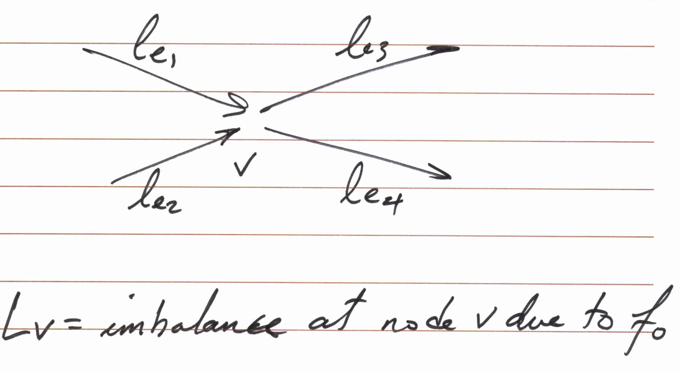

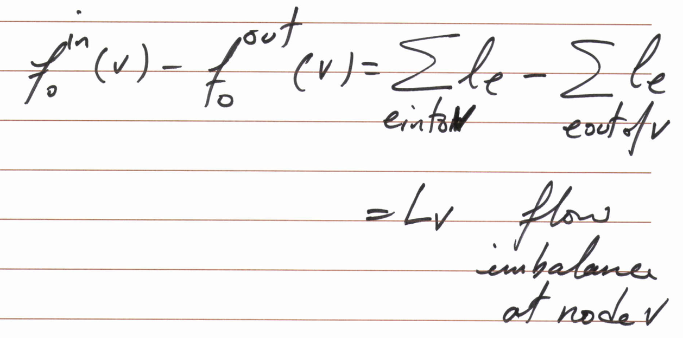



**Survey Design Problem**

* Input:
  + Information on who purchased which products
  + Maximum and minimum (upper bound) number (lower bound) of questions to send to customer i
  + Maximum and minimum number of question to ask about product j
* Objective: survey consumer i about product j only if they own it.
* Solution: in circulation network, add a path with infinite capacity from sink to source in order to keep circulation in the graph.

**Airline Scheduling Problem**

* Input: a list of flight segments with following information:
  + Origin
  + Destination
  + Departure time
  + Arrival time
  + Maintenance time required before each flight
  + Flight time between any two cities
* Objective: complete the schedule with minimum number of flights
* Solution:
  + Add super source and super sink to connect the segments.
  + To find the minimum number of planes (source), we need to use binary search to find the mim number as close as the lower bound.
* Overall time = O(k^3 * logk), but can solve in O(k^3) time by formulating as minimum flow problem

**Min Flow Problem**

* Input:
  + Directed graph G = (V, E)
  + Source s∈V
  + Sink t∈V
  + le for each edge e∈E
  + There are no Ce’s
* Objective: Find a feasible flow of minimum possible value.
* Solution:
  + Assign a “large” capacities to all edges and find a feasible flow f
  + Construct G`, where all the edges are reversed and the reversed edge e has capacity = fe - le
  + Find maximum flow from t to s in G`
  + Min flow = f- f`

**DP Problems Review:**

**String Partition problem (Zoom In / Zoom Out)**

* Question: the problem involves partitioning a given input string into disjoint substrings. Let C(i, j) be the given cost of each substring Xi…Xj. The cost of a partition is the sum of costs of substrings. We need to find the min-cost partition.
* Subproblem: OPT(j) be the min-cost partition X1X2…Xj
* Recurrence relation:
  + OPT(j) = min1≤k<j (OPT(k-1) + C(k,j))
  + OPT (0) = 0
* Complexity: O(n^2). Because we have an array with dimension n to store each unit substring (a, b, c…), and each unit substring needs O(n) comparison time.
* Conclusion: **it is a 1-D problem, the problem is not similar to matrix multiplication, it is an one-end zooming question**. We should avoid to use OPT(i, j) to define the subproblem because it will generate a larger complexity with O(n^3). We can start from OPT(1) to run the recursion function, and then reuse the previous results again and again until get the lat partition closed to j.

**Hotel Accommodation Problem (Use / Not Use)**

* Question: there are n customers interested in renting one of the two rooms for d[i] days and pay bid[i] for the entire stay. We need to accommodate them into two rooms in D days with max profit.
* Subproblem: OPT(d1, d2, i) is the max profit with d1, d2 remaining days for room 1 and 2, and using the first i customers.
* Recurrence relation:
  + OPT(d1, d2, i) = max(bid[i] + OPT (d1 − d[i], d2, i − 1),

bid[i] + OPT (d1, d2 − d[i], i − 1),

OPT (d1, d2, i − 1))

* OPT(d1,d2,0) = 0
* OPT(d1,d2,i) = -∞ if d1 < d[i] or d2 < d[i]
* Complexity: O(nD^2). Because we have two rooms with D days range and n customers (three loops).
* Conclusion: **it is a 3-D problem, the problem is similar to 0-1 knapsack problem**, but with two knapsacks (2 rooms in this problem). We should separate three conditions include two conditions with accommodating the i’s customer to one of these two rooms, and another condition without accommodating to any rooms. In addition, in the initial conditions, we need to initialize the impossible condition as negative infinite because we have to make sure the condition exceed to the maximum living days will not be selected by max function (if someone pay for a really high price).

**Workers Assignment Problem (Use / Not Use)**

* Question: we have N works, each one is assigned to work at one of M factories. The profit P(i, j) is defined by factors i with j workers. We need to find the assignment of workers to factories that produces the max profit.
* Subproblem: OPT(m, j) is the assignment of j workers to the first m factories that produces the max profit.
* Recurrence relation:
  + OPT(m, j) = max0≤k≤j [P(m, k) + OPT(m-1, j-k)].
* Complexity: O(mN^2). Because the time to compute each value OPT(m, j) is O(n) and there are mN subproblems.
* Conclusion: **it is a 2-D problem**, the profit function P(i, k) has already been given in the question, we can use it directly in our recurrence relation to calculate the maximum profit. Additionally, we need to recursively assign j-k workers with max profit to the first m - 1factories.

**Palindrom Problem (Zoom In / Zoom Out)**

* Question: given a string S = s1s2s3…sn, we need to find the longest palindromic subsequence.
* Subproblem: OPT(i, j) is the length of longest palindrome in Si…Sj
* Recurrence relation:
  + OPT(i, j) = 2 + OPT(i - 1, j - 1)
  + OPT(i, j) = max(OPT(i, j-1), OPT(i+1, j))
* Complexity: O(n^2). Because for string of size n, we need to create a 2-D table to store current value of i and j.
* Conclusion: **it is a 2-D problem, the problem is similar to matrix multiplication, which is a two-end zooming question**. To solve the problem, we can also reverse the entire string, and then find the LCS of two string.

**Divide Half Problem (Use / Not Use)**

* Question: given n blocks with tattoo weight of W, we need to arrange them into 2 piles, which the weight difference of the two piles is as smaller as possible. Also, determine which block will go into which pile.
* Subproblem: P(i, w) has the value TRUE if it is possible to make a pile of weight w≤W/2 with some subset of blocks 1 through i, and the value FALSE otherwise.
* Recurrence relation:
  + P(i, w) = P(i-1, w) U P(i-1, w - wi)
  + P(i-1, w-wi) = FALSE if wi > w
  + P(0, 0) = TRUE
  + P(0, w) = FALSE for all values when w > 0
  + We need to create another table B(i, w) which of P(i-1, w) or P(i-1, w-wi) was TRUE (choose arbitrarily if they are both TRUE)
  + Find the largest value for which P(n, w) is TRUE, then trace back using table B to determine which blocks in which pile
* Complexity: O(nW). Because there are O(nW) subproblems.
* Conclusion: **it is a 2-D problem, the problem is similar to LeetCode 416.** In order to let two piles have the most similar weights, we should let them be as close as W/2. So we create a subproblem that only arranges half of the items in one pile, the rest of items will be on the other pile. To traceback each item, we should create a second table to store which statement makes each subproblem to be TRUE.

**Number Adding Problem (Decision Tree)**

* Question: Given a number n, we need to find the number of ways to write n as the sum of numbers 1,3, and 4. Eg, for n=5, the answer is 6 (1,1,1,1,1; 1,1,3; 1,3,1; 3,1,1; 1,4; 4,1).
* Subproblem: C(n)
* Recurrence relation:
  + C(n) = C(n-1) + C(n-3) + C(n-4), when n > 4
  + Base cases: C(1) = 1, C(2) = 2, C(3) = 3, C(4) = 4.
* Complexity: O(n)
* Conclusion: it is a 1-D problem, but not exactly similar to 0-1 knapsack problem. Because it is not a simple question with using or not using the i item, but it considered permutation. So we can consider the question as that the condition we use the last number. For example, for C(5) = C(4) + C(2) + C(1). C(4) means we use 1 as the last adding number. However, if we only consider combination, it is similar to 0-1 knapsack problem.